IT24100925

Premathilaka H.K.H.P

IT2120

Labsheet 05

Exercise 02

01.

02.

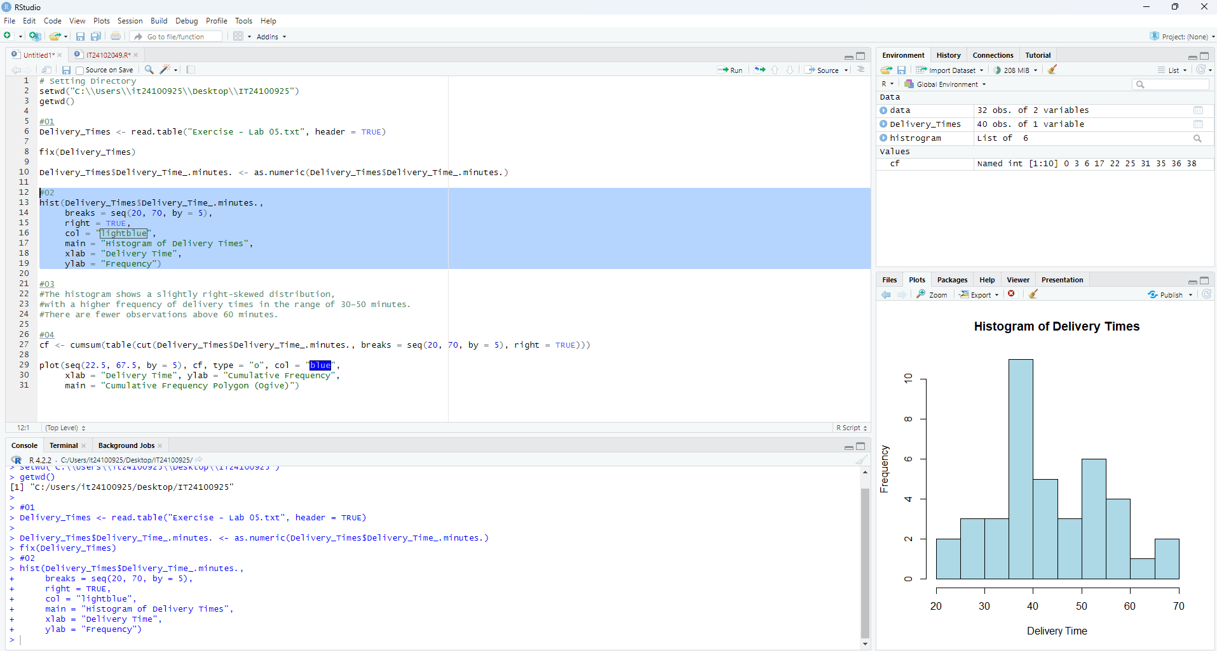

03.

#The histogram shows a slightly right-skewed distribution,

#with a higher frequency of delivery times in the range of 30–50 minutes.

#There are fewer observations above 60 minutes.

04.

